Subject: Weekly Update April 11 – April 17, 2024

Date: April 18, 2024

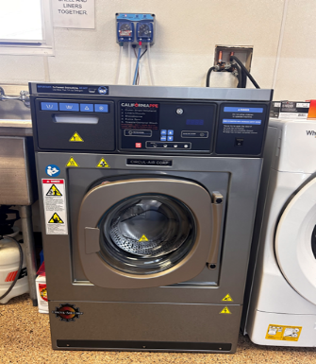
FIRE DEPARTMENT
Report
Colton Fire Station 2 provided station tours and static displays to students from Grant Elementary School on Monday April 15th and Tuesday April 16th.

Colton Fire took delivery of two new extractors for cleaning turnout gear. These are state of the art, which automatically inject the proper amount of cleaning agents to remove carcinogens and disinfectants to remove any bloodborne pathogens. The two new NFPA 1851 certified extractors will replace our two older non-compliant extractors.

COMMUNITY SERVICES
Outreach Partnership Meeting
The Homeless Prevention and Resources Program hosted a multi-agency meeting on April 16 with non-profit organizations and government agencies to seek in person outreach assistance with unhoused individuals, who reside within the City’s borders. The meeting was well attended with over 10 agencies represented by 25+ attendees. The meeting consisted of reviewing the City of Colton’s current Homeless Prevention and Resources Programs and the three largest homeless encampments within the city. Several agencies were able to share what work their agencies do within the city already. Our staff made several new connections that will hopefully develop into partnerships that bring added services into those residing in Colton.
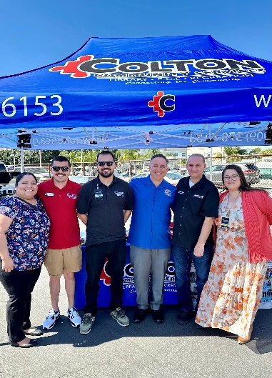

ARMC EMS Day The Recreation Division Aquatics Team was out at EMS Day on April 17 at Arrowhead Reginal Medical Center to spotlight the summer recruitment for Lifeguards and Senior Lifeguards. Many event participants stopped by the booth and expressed interest in the two aquatics positions. Our team was especially pleased to find that many participants recognized the department branding and came by to say hello.

Volunteer Interviews
This week has been dedicated to interviewing this year’s 41 VolunTEEN applicants who are 13-15 years of age. Of those interviewed, 15 will be selected to join the summer VolunTEEN program in the Community Services Department. Each VolunTEEN gains 150 hours of work experience over the summer and will receive a $500 stipend at the close of the program. This year’s applications were more than doubled than the previous several years and we believe this is due to the stipend increase approved last year.

National Library Week 2024
The Colton Public Library celebrated National Library Week during the second week of April! The library hosted a week filled with special events, workshops, and good times! On Monday 4/8, the Main Library hosted a family centered magic show starring Zany Zoe. The main floor area of the Main Library was filled with magic enthusiasts of all ages! On Wednesday 4/10, the Main Library Hosted a healthy cooking workshop lead by Chef Alonso. All patrons in attendance were treated to a Hawaiian BBQ and learned how to make healthy choices and changes to traditional recipes to share with their families and friends. On Thursday 4/11, the Luque Branch Library hosted a wildlife and reptile show. Thor and his slippery and slimy friends were a huge hit with our young library patrons! Participants learned about creepy crawly spiders, tortoises, lizards, and snakes! National Library Week wrapped up with the annual Friends of the Library’s Booksale on 4/13. The generous proceeds raised from the book sale go to the continued support of library needs and sponsorship of special events.

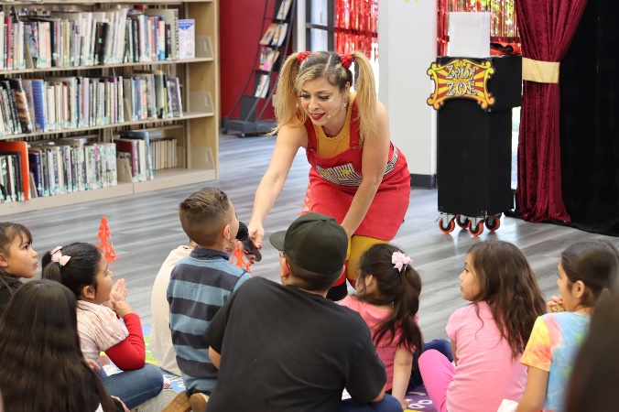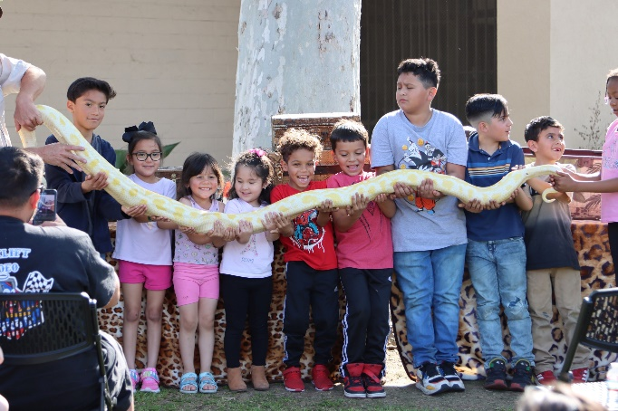

Week of the Young Child
On Saturday, April 13, 2024, the Early Care and Education Division hosted the inaugural Week of the Young Child (WOYC) event at Fleming Park from 8:30 to 11:30 am. WOYC, a national initiative by the National Association for the Education of Young Children (NAEYC), aims to celebrate the significance of childcare and development. ECE has been actively involved in WOYC for several years, traditionally organizing activities at each of its four facilities. However, this year marked an expansion of efforts, with the hope that this inaugural event will become a regular fixture for ECE and the community.

The event, which attracted over 300 attendees including ECE staff, children with their families, and community members, was deemed a resounding success! More than 150 swag bags were distributed to children, enhancing the festive atmosphere. The entire event was offered free of charge and featured various attractions such as a breakfast provided by the Lions Club, jumpers, lawn games, arts and crafts, family-friendly activities, face painting, temporary tattoos, a DJ, a photo booth, and a vendor section offering valuable resources to ECE families. Notable attendees included representatives from the Fire Department, Police Department, Electric Department, and Council Member Toro. It's worth mentioning that, given the novelty of the event, ECE heavily relied on the expertise of Recreation and its staff, particularly Recreation Coordinator Razili Ramirez.

A highlight of the day was the unexpected appearance of Assembly Member and Majority Leader Eloise Gomez Reyes, who presented the Colton ECE Division with a Certificate of Recognition. This recognition acknowledged their outstanding contributions and unwavering dedication to Early Care and Education.

POLICE DEPARTMENT
Announcements
- Please join us in welcoming Police Officer Trainee Kassandra Ramirez who started on April 15, 2024.

Notable Arrests/Investigations/Incidents
- April 17, at 10:35 p.m., (Suicide), officers responded along with the Fire Dept. to the 1800 block of Evelyn Circle in reference to a reporting party locating a seventy-year-old family member who appeared deceased. Fire Dept. pronounced the subject. The San Bernardino County Coroner’s Office responded to the location and took over the investigation. Report forwarded to Detective Division.

- April 17, at 3:06 p.m., (Death Investigation), Colton Fire Department requested Colton Police to respond to the 200 block of Balbirnie Avenue in reference to a deceased subject. Upon arrival, the San Bernardino County Coroner’s office was contacted, and they took over the investigation.

- April 17, at 2:28 p.m., (Death Investigation), officers responded to subject not breathing in 1800 block of Ellen Circle. Upon arrival, the subject was found to be deceased. The San Bernardino County Coroner’s office responded to the location and took over the investigation.

- April 16, at 12:30 p.m., (Injured Animal), officers and ACO responded to “C” Street and Hermosa Avenue in reference to a dog hit by a train. Due to the size and injuries suffered, the veterinarian asked that the animal be euthanized prior to transport. The animal was euthanized per Colton Police policy 808.12.

- April 15, at 12:20 p.m., (Resist Arrest), officers attempted to contact a subject that was walking in traffic at La Cadena Drive and “L” Street. The subject became aggressive with officers and was eventually arrested and found to have an active warrant. The suspect was transported to West Valley Detention Center.

- April 14, at 9:51 p.m., (Attempt Homicide), officers responded to the 200 block of E. “C” Street in reference to a shooting that had just occurred. The suspect fled the scene prior to police arrival. The victim, who was conscious and communicative, sustained gunshot wounds to his upper torso and was transported to local hospital. Case forwarded to Detective Division for follow-up.

- April 14, at 8:05 p.m., (Recovered Stolen Vehicle), officers responded to the area of Mount Vernon Avenue and Washington Street in reference to a License Plate Reader hit. Officers located the vehicle, arrested the driver, and booked him at West Valley Detention Center.

- April 14, at 6:23 p.m., (Brandishing a Weapon), officers responded to the 1600 block of E. Washington Street for a report of three subjects at the complex with guns, threatening to kill the reporting party. Officers arrived at the location and detained three subjects matching the description. The reporting party later advised those were not the subjects and they were released. Another identified male had fled the scene prior to police arrival.

- April 14, at 4:46 p.m., (Failure to Yield), An officer conducted a traffic enforcement stop on a vehicle in the 400 block of Sperry Drive. The subject fled from the officer while throwing narcotics out of the vehicle. The suspects were able to elude the officer. The vehicle was discovered abandoned in the City of San Bernardino.

- April 13, at 4:38 p.m., (Brandishing a Weapon), officers responded to the 800 block of E. Washington Street for a report of a male subject brandishing a handgun at someone. Upon arrival, the reporting party also alleged the subject had abducted her child. Officers were able to locate the suspect and detained him. The child was found safe. The investigation revealed that the allegations to be unsubstantiated.

- April 13, at 3:05 p.m., (Felony DUI), officers responded to Pepper Avenue and San Bernardino Avenue for a report of a traffic collision. The investigation revealed that a motorist collided with another motorist, who then collided into a fire hydrant and an electrical pole. City Electric was notified. The driver of the striking vehicle was found to be DUI and placed under arrest. A City Property Damage Form was taken and forwarded to Risk Management.

- April 12, at 8:43 p.m., (Carrying a Concealed Weapon), officers responded to an individual within the park, who was in possession of a firearm. Officers detained the individual, who was 16 years old, and located a firearm in his possession. The suspect was arrested and booked at juvenile hall.

- April 13, at 5:09 a.m., (Driving Under the Influence), officers responded to a vehicle that collided into a pole. Upon arrival, officers discovered a vehicle collided into a City owned street light pole, causing the pole to be sheered at the base and blocking the eastbound lanes. The suspect was arrested for DUI. City Streets and Electric Dept. responded to the scene. A City Property Damage Form was completed and routed to Risk Management.

- April 13, at 12:09 a.m., (False Imprisonment), officers responded to the 200 block of Maryknoll in reference to an intoxicated person causing a disturbance inside the residence. Upon arrival, the suspect locked the front door, armed himself with a knife and held the girlfriend inside against her will. Officers were able to arrest the suspect. The suspect was booked at West Valley Detention Center.

- April 12, at 2:52 p.m., (Injury Traffic Collision), officers responded to Westwind Street and Eucalyptus Avenue for a report of a vehicle striking a pedestrian. Upon arrival, a juvenile was located suffering from moderate injuries. The juvenile was transported to a local hospital for treatment.

- April 12, at 10:52 a.m., (Carrying a Concealed Weapon), officers responded to a business located in the 800 block of Valley Boulevard for a report of a homeless subject pointing a firearm at passing vehicles. Upon arrival, the male subject was located and detained. He was found to have a loaded firearm in his possession and placed under arrest. The suspect was booked at West Valley Detention Center.

- April 11, at 11:13 p.m., (Burglary), officers responded to the Teen Center, located at 651 N. Mount Vernon Avenue, in reference to a burglary in-progress. During an area check, officers located the suspect, who was in possession of approximately $3,000 worth of property that was taken from the center. The suspect was arrested and booked at West Valley Detention Center. City personnel responded and took possession of the stolen property and secured the broken door.

- April 11, at 5:10 p.m., (Assault with a Deadly Weapon), officers responded to a two-vehicle traffic collision that occurred on Pennsylvania Avenue and Mill Street. While responding to the location, dispatch advised that one of the drivers hit the other driver with a bat. Upon arrival, both subjects made conflicting statements and were uncooperative. The case will be submitted to the District Attorney’s office for review.

Stats

April 11, 2024 through April 17, 2024

Calls for Service 1274

Code Enforcement
Open Cases 265

