From: Dedie Lopez
Sent: Sunday, May 11, 2008 7:59 AM
To: Dedie Lopez
Subject: PE: Colton Palms senior housing complex to be torn down

Colton Palms senior housing complex to be torn down

10:00 PM PDT on Saturday, May 10, 2008
By CINDY MARTINEZ RHODES
The Press-Enterprise
The glitz of its art deco styling long gone, the Colton Palms senior apartment complex remains an empty shell -- and a sad reminder of what it was and what it should have been.
Opened in August 1991, the 101-unit low-to-moderate-income units were the showpiece of Colton's downtown. Six years later, problems with the construction surfaced, leading to the eventual closing of the complex and relocation of the senior citizens who once called it home.
Within the next four months, the city expects Colton Palms to be razed, closing a bitter chapter for some of the city's most vulnerable residents.
Story continues below
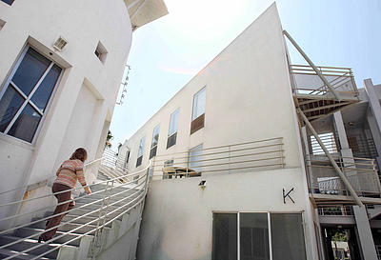
Ramon Mena Owens / The Press-Enterprise
Candace Cassel, Colton's economic development director, visits the now closed Colton Palms senior apartment complex, which will be razed. "When the building is down, it's going to be part of a healing process for the city," Cassel says.
"When the building is down, it's going to be part of a healing process for the city," Economic Development Director Candace Cassel said. "Right now, it's a very difficult reminder. The residents loved that complex and the sense of community they had. It wasn't necessarily the bricks and mortar part; it was the community, the relationships. Colton is home."
Of Colton's 52,000 residents, 11.6 percent are older than 55, Cassel said. As one of the conditions of the city's $5.75 million settlement with the architect and the construction company, replacement housing must be built within four years of its closing, or by August 2011.
Where it will be built is a point of debate.
Story continues below
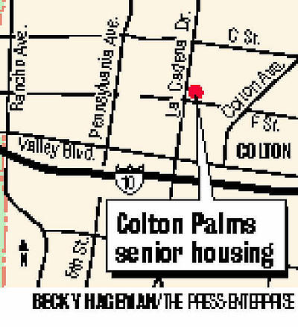
In 2005, the City Council identified the northwest corner of Mount Vernon and Colton avenues as the site for the new senior units. Some people balked, however, saying that corner has too much traffic. Many would prefer the city rebuild on the same site on La Cadena Drive, next to the Police Department and Colton City Hall.
That is where the conflict occurs. The council would like to use the Colton Palms site to expand both City Hall and the police station.
Story continues below
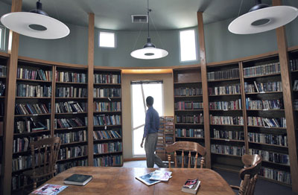
Ramon Mena Owens / The Press-Enterprise
Ali Pezeshkpour, Colton's project manager, checks out the library of the defunct Colton Palms senior apartment complex. The complex was once the showpiece of the city's downtown area.
Mayor Kelly Chastain said she is open to either location, or another option if one presents itself.
"We're (civic center) running short on room, but maybe if they built a combination with retail downstairs and upstairs could be senior housing," Chastain said. "If it's developed in the right manner, it could be very useful."
City Councilman David Toro, whose mother lived at Colton Palms for 14 years, is on the council subcommittee on senior housing. He said the timing is wrong and the funding is not available for expansion when there are so many other basic needs in the city.
"How can we build a grand, illustrious (City Hall) building when we need city housing and sports complexes?" Toro asked. "They just remodeled the civic center, and we're accommodating people in a timely manner there.
"I think the prime location (for senior housing) is right where it's at," he said. "Since the day I got on City Council, one of my first things was to try to get senior housing back at Colton Palms."
Reach Cindy Martinez Rhodes at 909-806-3054 or crhodes@PE.com

